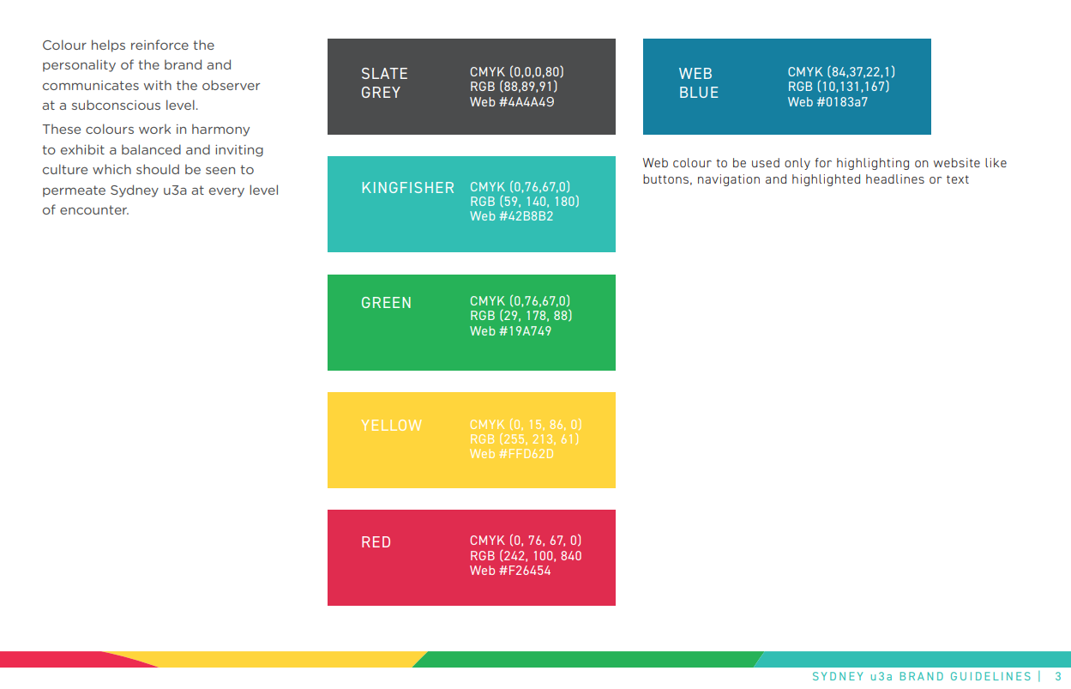
#4A4A49, #0183a7, 42B8B2, #19A749, #FFD62D, #F26454
RGBA(88,89,91,.40), RGBA(10,131,167,.40), RGBA(59,140,180,0.40), RGBA(29,178,88,.40), RGBA(255,213,61,.40), RGBA(242,100,840,0.40)
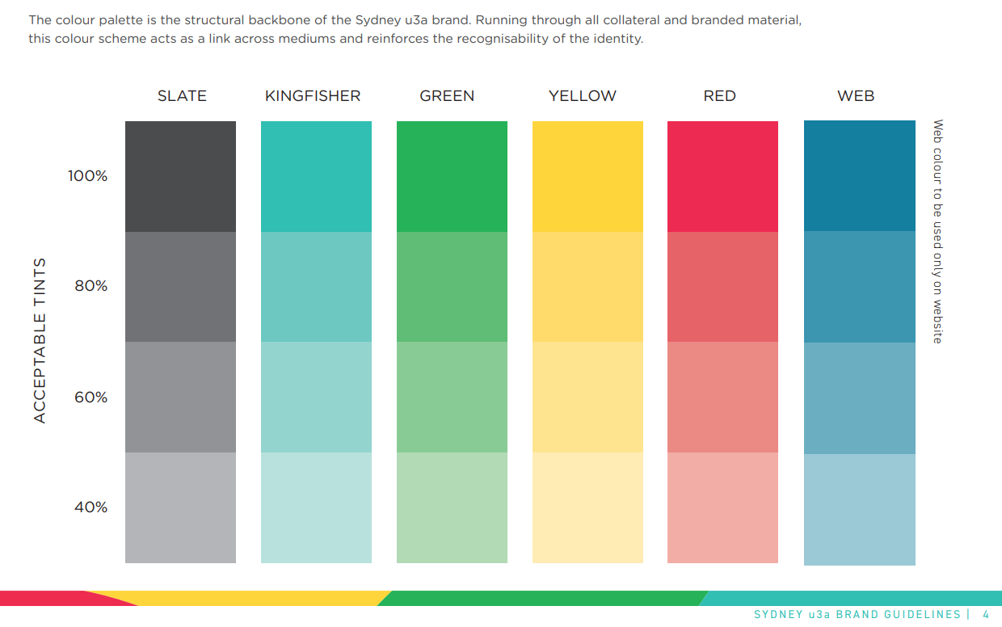

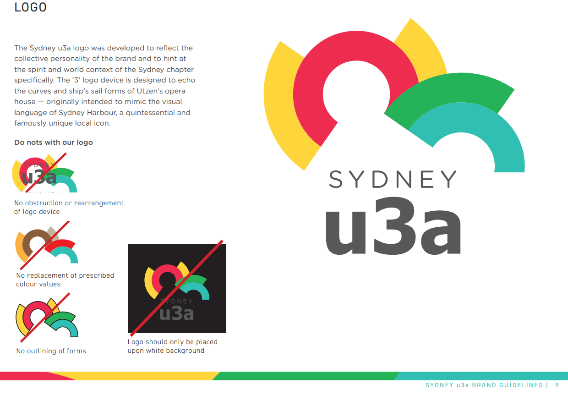
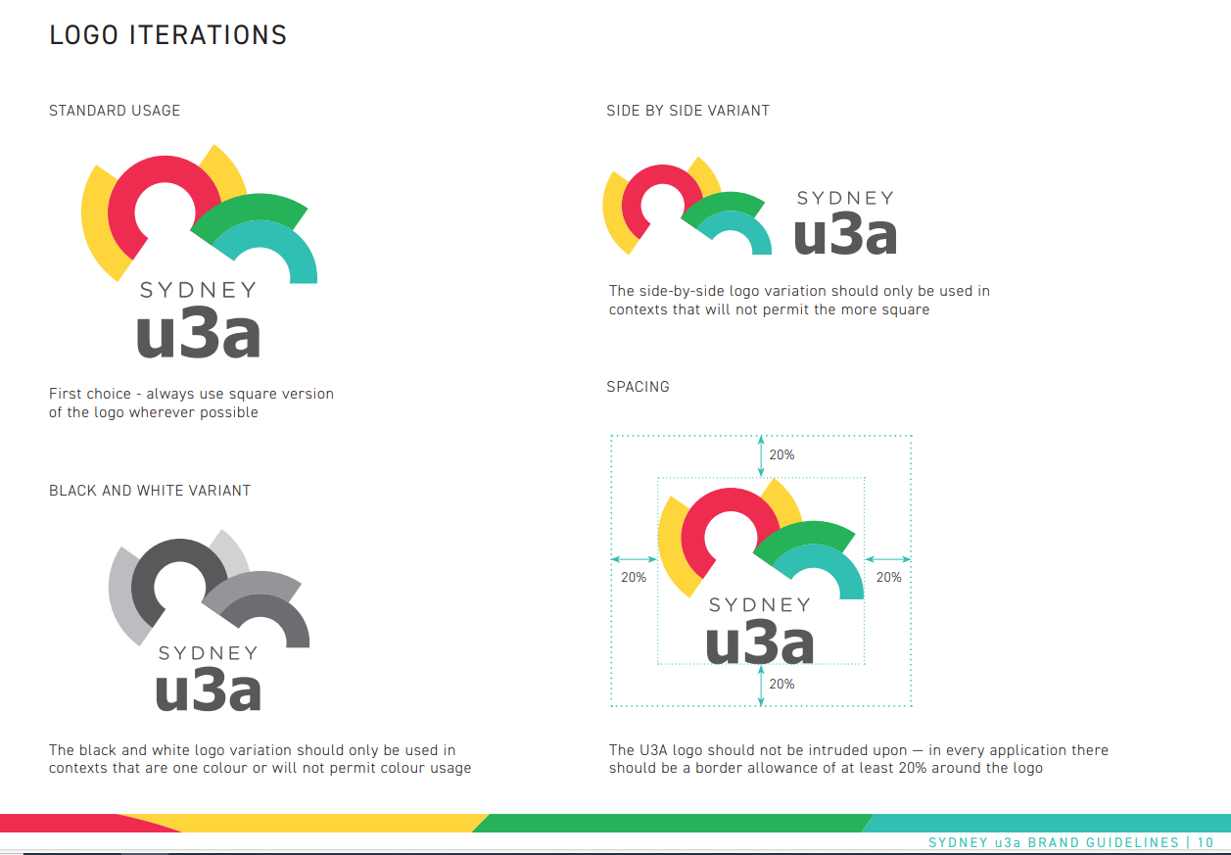
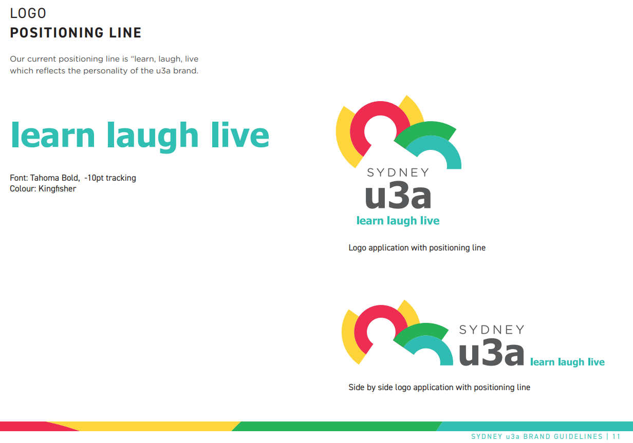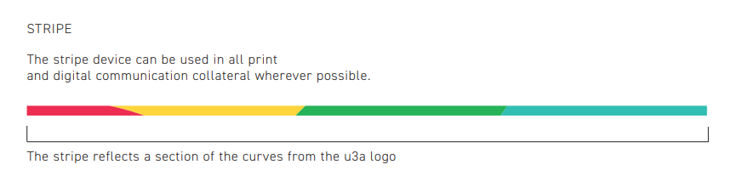

Fonts
- Gotham rounded for headings
- Prompt for body text

